EXPERIMENT-7

AIM: TO WRITE SQL QUERIES TO PERFORM SPECIAL OPERATIONS(i.e

LIKE,BETWEEN,ISNULL,ISNOTNULL)

**Creating a table**

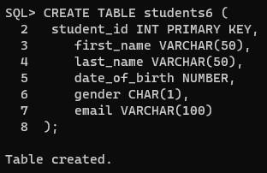

**Inserting values :**

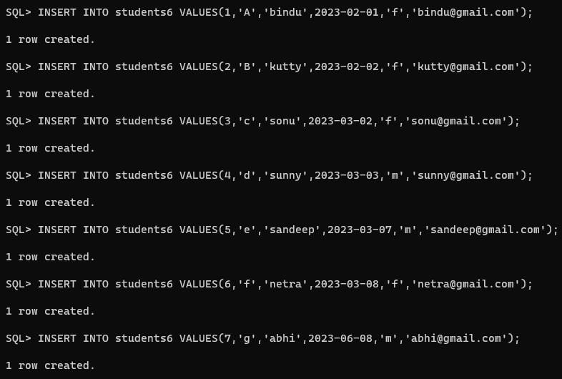

**Is Null operation :**

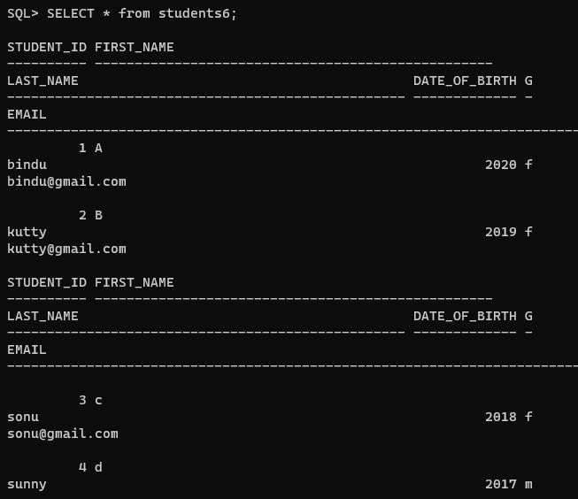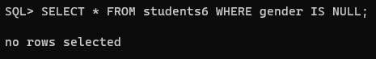

**Is not null operation :**

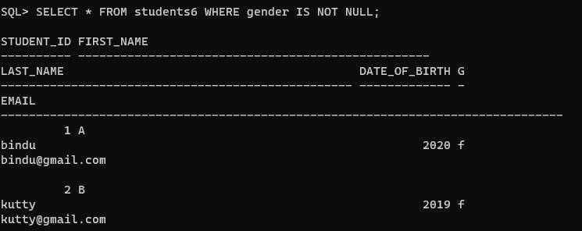

**Between operation :**

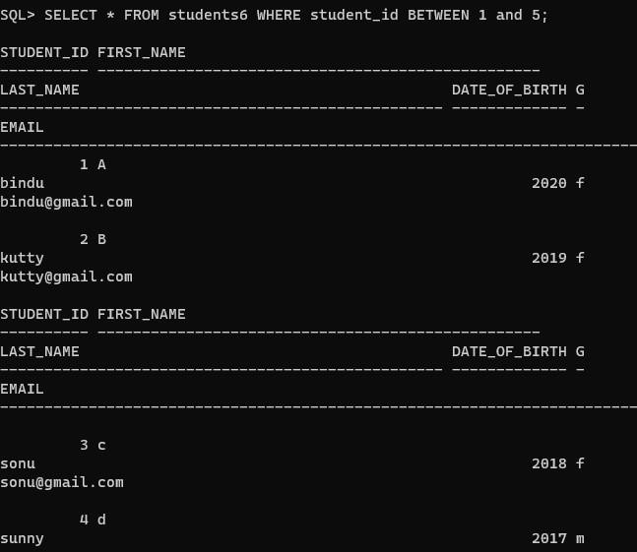

**Like operation:**

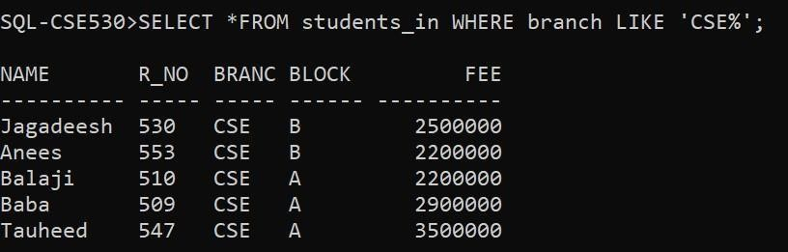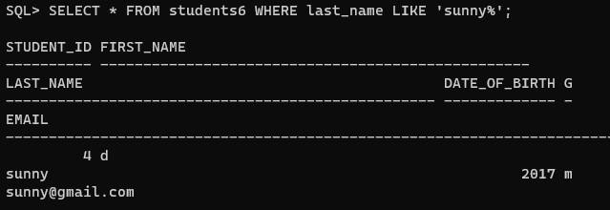

**Exists operation :**

